Corpus Christi Procession
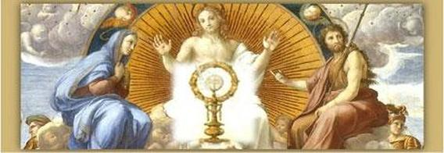
Thursday, June 20th Following 6:00pm Mass
St. Isaac Jogues to Notre Dame
Come and be a literal follower of Jesus and take part in this awe-inspiring, musical, festive, candlelight Eucharistic Procession of praise, and pageantry, marching shoulder to shoulder with hundreds of Catholics alongside seminarians, priests, nuns in a powerful public witness, bringing Jesus out into the public square, and letting Him transform our families, parishes and communities.
Enjoy an unforgettable mile long stroll, or ride the trolleys, on a spring evening with families, friends and Jesus Himself from St. Isaac Jogues in Hinsdale to Notre Dame in Clarendon Hills on the Feast of Corpus Christi, followed by a unique, moving Benediction, food, drink, and Christian community. You’ll be glad you did, and so will Jesus.
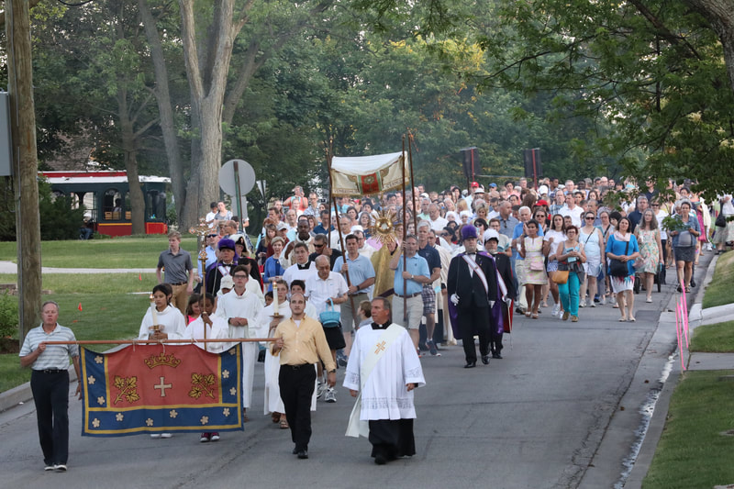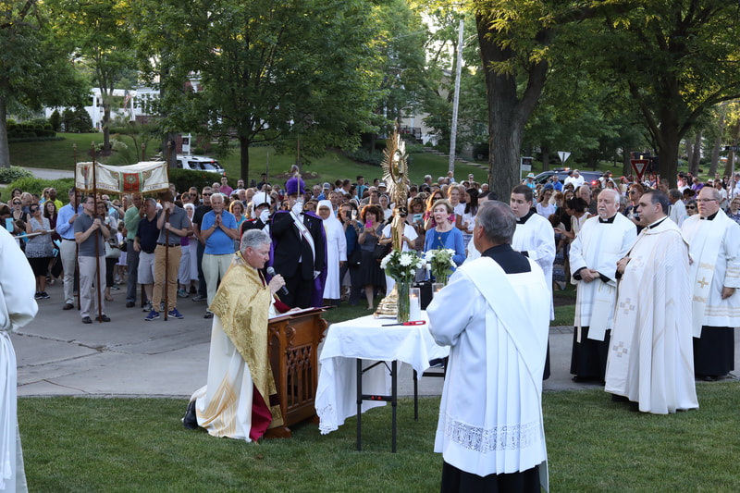

Come and See on Thursday June 20th, beginning with 6:00 pm Mass, or go to www.sij.net to find out more.
The Evangelization Outreach Committee of St. Isaac Jogues

